January 2019 | The Official Home of…
 | 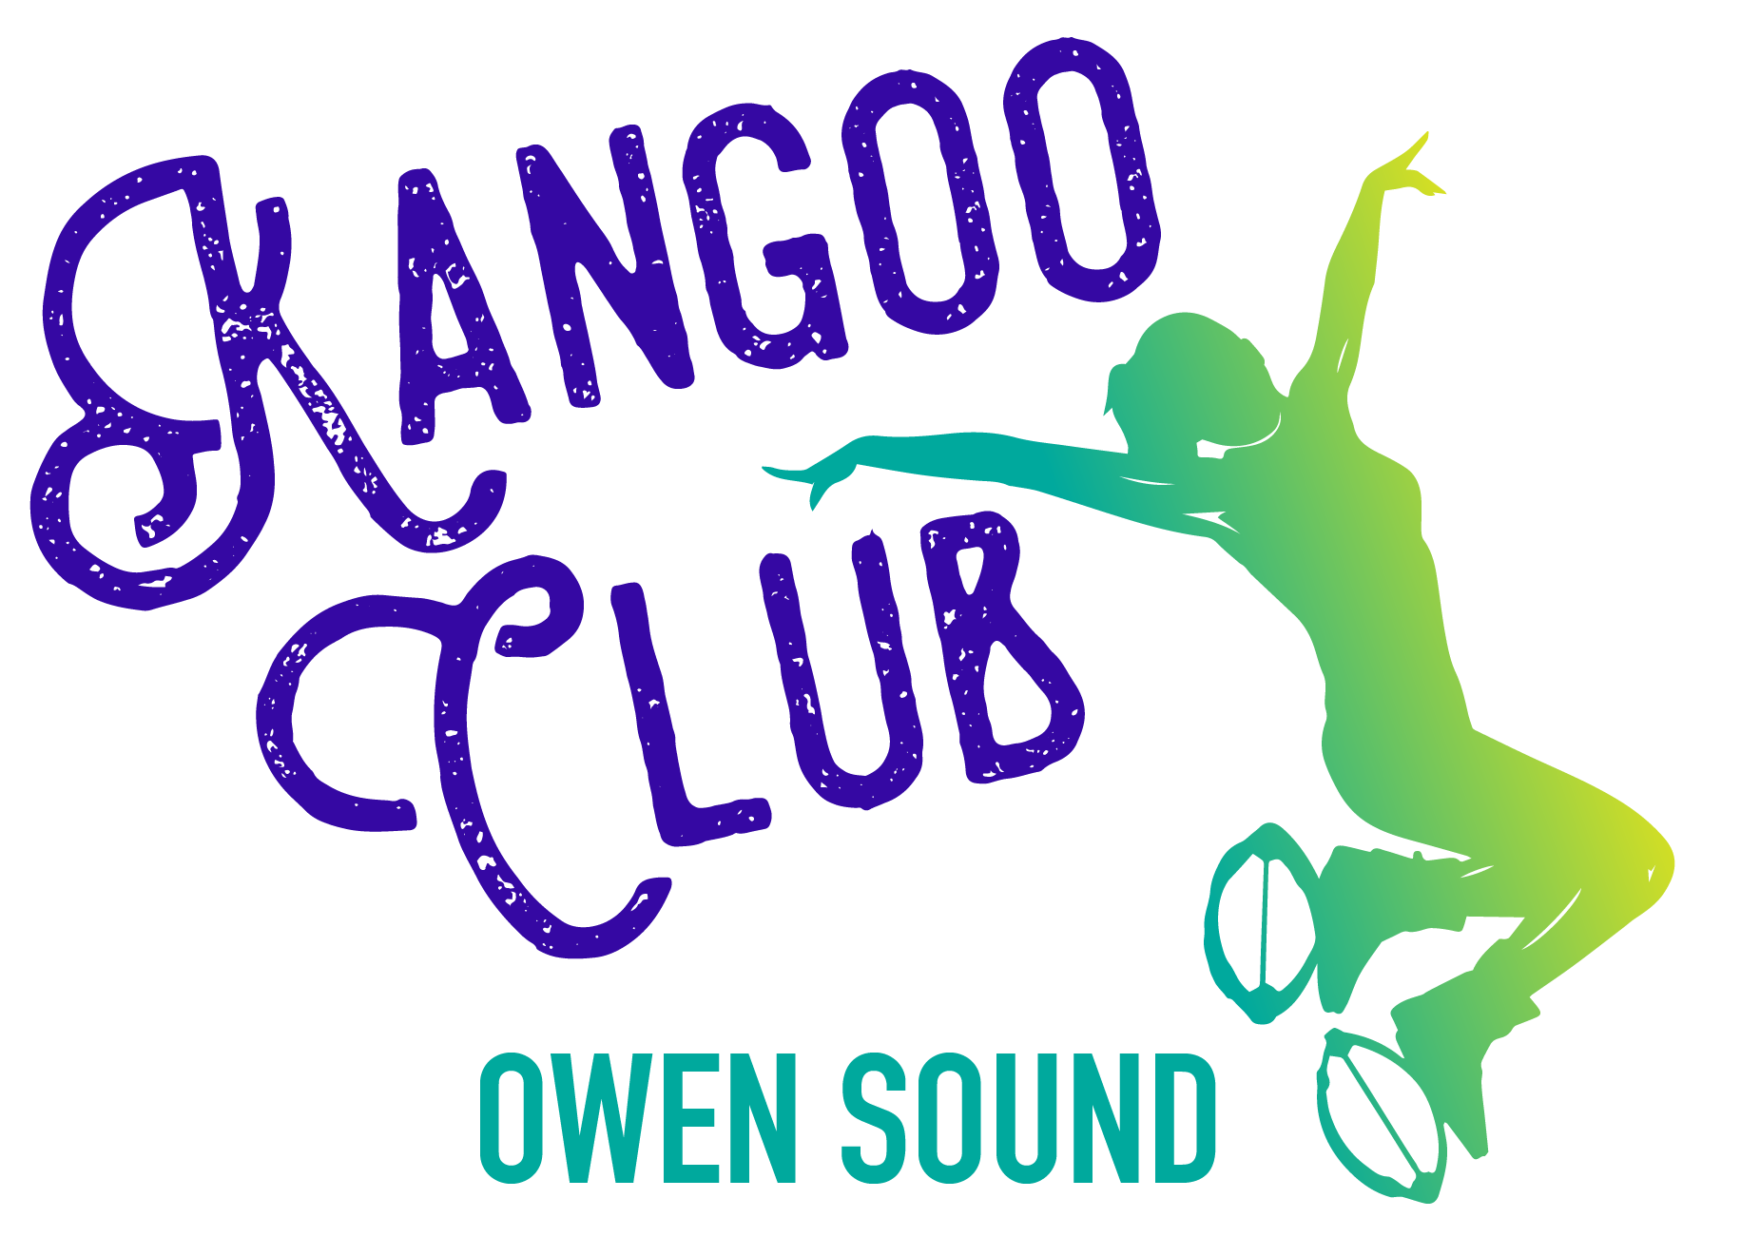
 | 640 10th Street West, Owen Sound
Sunday | Monday | Tuesday | Wednesday | Thursday | Friday | Saturday
 |  | 1 | 2 | 3 | 4 | 5
 |  |  | Beginner Kangoo  5:30-6:15pm |  | Yoga Flow With Dawn  6pm | Kangoo Bootcamp  10am
6 | 7 | 8 | 9 | 10 | 11 | 12
 |  | Bootless Boot- camp 5-5:45pm  Gentle Yoga 6pm | Beginner Kangoo  6-6:45pm | Kangoo  6pm |  | Yoga Flow -9am  Kangoo- 10:30am
13 | 14 | 15 | 16 | 17 | 18 | 19
 | Kangoo  6:30pm | Gentle Yoga  6pm | Beginner Kangoo  7pm | Kangoo Bootcamp  6pm |  | Kangoo  9am
20 | 21 | 22 | 23 | 24 | 25 | 26
 | Kangoo  5pm | Gentle Yoga  6pm |  |  |  | Yoga Flow  9am
27 | 28 | 29 | 30 | 31
 |  | Gentle Yoga  6pm |  | Kangoo  6pm

The brand new MissFit Studio is the official home of Kangoo Club Owen Sound! | Drop-in Kangoo classes are $15 (incl. boot rental)  6 class passes for $90- your 7th class is FREE!! | Dawn Smith offers a variety of yoga classes. For info/registration email:  tdawnsmith14@  gmail.com | January Special:  UNLIMITED KANGOO classes for just $70 (incl. boot rental) | Ask about MissFit Personal Training packages- offered by Miranda Smit  RMT, CPT | Kangoo Jumps exercise programs burn up to 30% more calories than any other activity!
Follow us on Facebook and Instagram! missfitstudio@hotmail.com 519-379-4672

