September
2019
640 10th Street West, Owen Sound missfitstudio@hotmail.com/519-379-4672
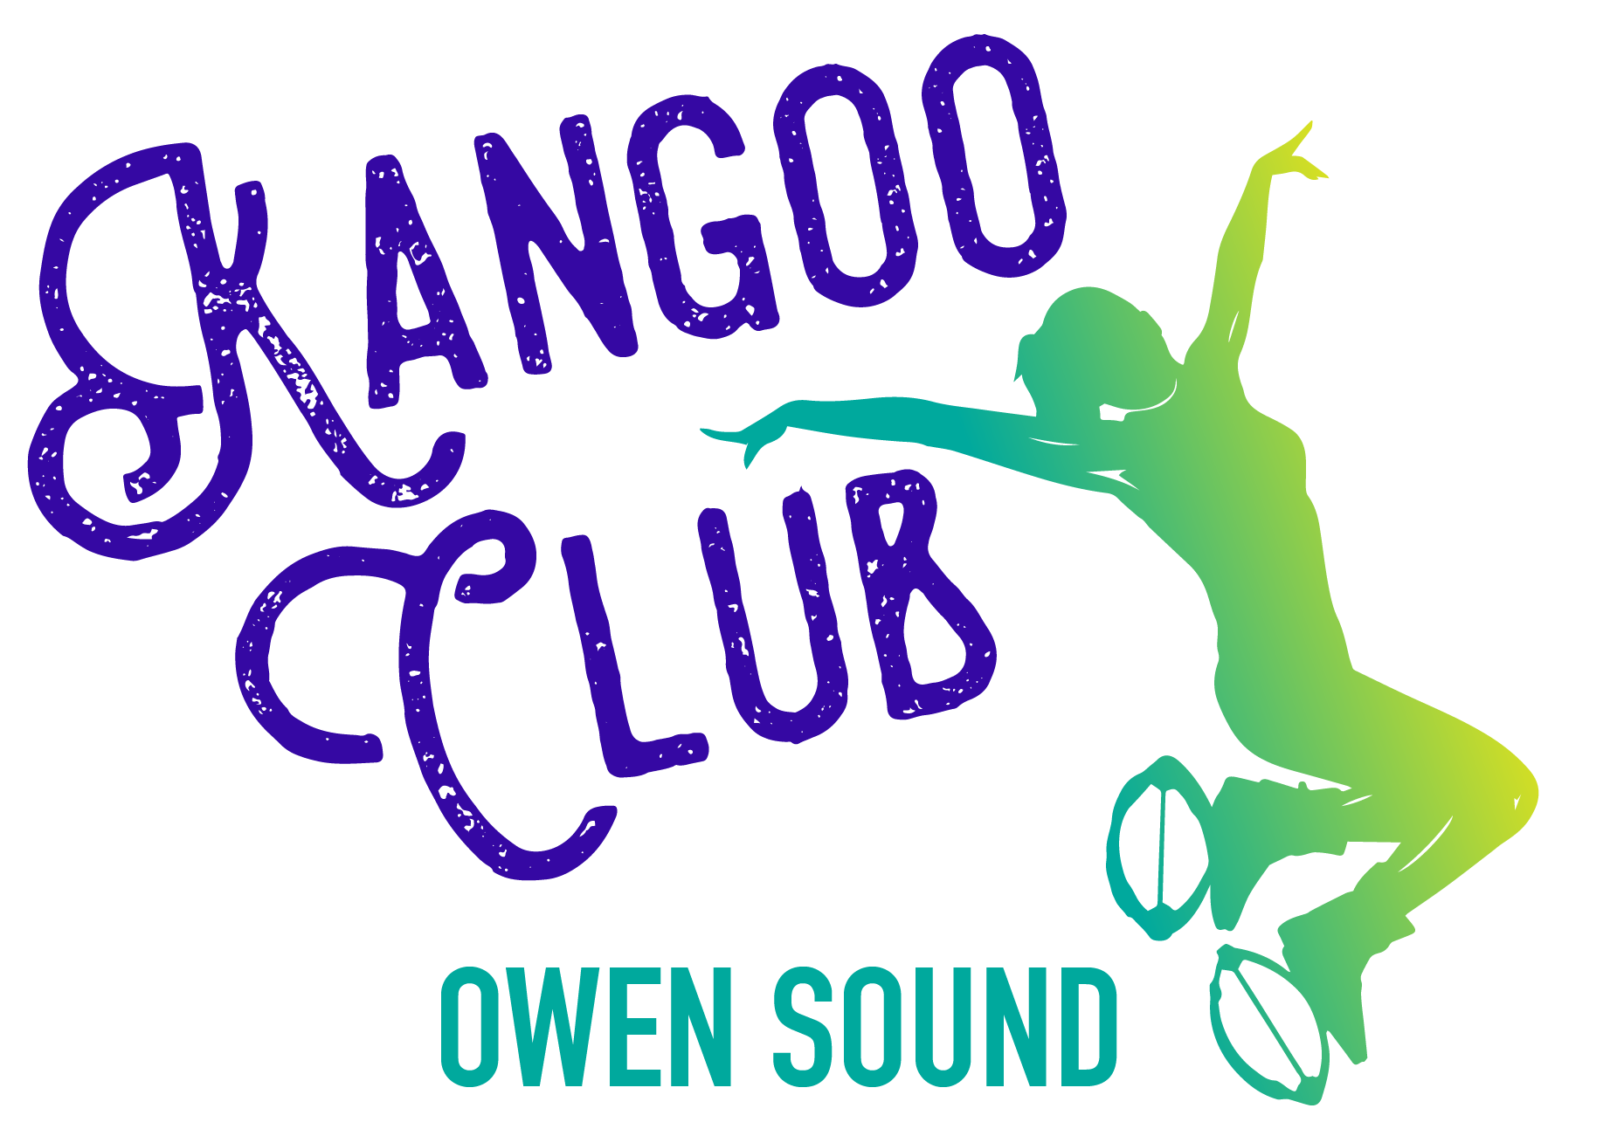
Sunday | Monday | Tuesday | Wednesday | Thursday | Friday | Saturday
1 | 2 | 3 | 4 | 5 | 6 | 7
 | Kangoo in the Park-11am at Harrison Park |  | Drop-in Bootcamp 12:10-12:50 | Beginner Kangoo 5:45pm  Kangoo 7pm | Drop-In Bootcamp  12:10-12:50 | Kangoo POWER 9am  Active Yoga Flow 10am
8 | Drop-In Bootcamp 12:10-12:50 9 | 10 | 11 | 12 | 13 | 14
 | Beginner Kangoo 5pm  Yoga with Whitnee 7-8:15pm | Kangoo Kick and Punch and Core Conditioning 7pm  (30 min. each) |  | Kangoo 7pm |  | Active Yoga Flow 10am
15 | Drop-In Bootcamp 12:10-12:50 16 | 17 | 18 | 19 | 20 | 21
 | Kangoo Dance 5pm  Yoga with Whitnee 7-8:15pm | Kangoo 6pm | Drop-In Bootcamp  12:10-12:50 | Beginner Kangoo 5:45pm  Kangoo 7pm |  | Active Yoga Flow 10am
22 | Drop-In Bootcamp 12:10-12:50 23 | 24 | 25 | 26 | 27 | 28
 | Beginner Kangoo 5pm  Yoga with Whitnee 7-8:15pm | Kangoo Kick and Punch and Core Conditioning 6pm  (30 min each) | Drop-In Bootcamp  12:10-12:50 | Kangoo Dance  7:30pm |  | Kangoo POWER 9am  Active Yoga Flow 10am
29 | Drop-In Bootcamp 12:10-12:50 30 |  |  | September Beginner Special: | Register and pay in advanced for three (or more)
 | Kangoo 5pm  Yoga with Whitnee 7-8:15pm |  |  |  | Beginner Kangoo classes and get $10 off!
Get a month of UNLIMITED Kangoo/Core/Bootcamp for just $85, OR drop-in Kangoo for $15/drop-in Bootcamp for $10
Purchase 8 Yoga classes for $100, OR drop-in Yoga for $15.
Contact Us:
Miranda Smit, CPT missfitstudio@hotmail.com 519-379-4672 Follow us on Facebook and Instagram!

