December
2019
640 10th Street West, Owen Sound missfitstudio@hotmail.com 519-379-4672

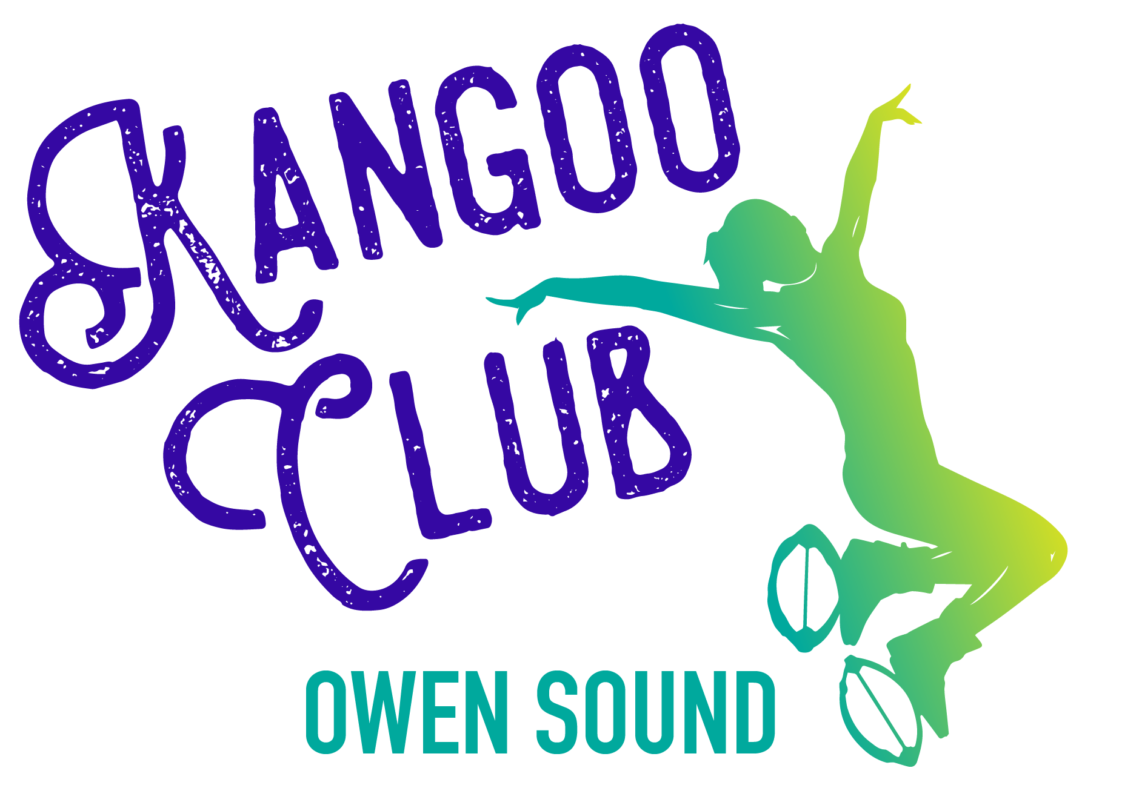
Home of Kangoo Club Owen Sound!
Purchase an unlimited class pass this month for only $75, or a six class pass for just $80 with boot rental/$50 with your own boots !
Sunday | Monday | Tuesday | Wednesday | Thursday | Friday | Saturday
1 | Drop-In Bootcamp 12:10 2 | 3 | 4 | 5 | 6 | 7
**Yoga, Meditation and Vision Board with Dawn 2-4pm  Cost: $20 | Beginner Kangoo 5:30pm  Kundalini Yoga 7pm | Kangoo 7pm |  | Kangoo Dance 7pm | Drop-In Bootcamp 12:10 | Power Yoga 10am
8 | Drop-In 9 Bootcamp 12:10 | 10 | 11 | 12 | 13 | 14
 | Beginner Kangoo 5pm  Kundalini Yoga 7pm | Kangoo Kick and Punch 6pm  Core Conditioning 6:30pm |  | Kangoo 7pm | Drop-In Bootcamp 12:10 | Power Yoga 10am
15 | 16 | 17 | 18 | 19 | 20 | 21
 | Kangoo 5pm  Kundalini Yoga 7pm | Kangoo 7pm |  |  | - Kangoo 5pm  Core Conditioning 6pm | Power Yoga 10am
22 | 23 | 24 | 25 | 26 | 27 | 28
 | Drop-In Bootcamp 12:10 |  | Merry Christmas!!   |  | Kangoo 5pm | Power Yoga 10am
29 | 30  Drop-In Bootcamp 12:10 | 31
 | Kangoo 5pm
Get a month of UNLIMITED Kangoo/Core/Bootcamp for $75, OR Drop-In Kangoo for $15/Drop-In Bootcamp for $10
Registration for Kundalini Yoga contact Whitnee at morningmoonyoga@gmail.com
Registration for Active Yoga contact Dawn at baysongyoga@gmail.com
Miranda Smit RMT, CPT missfitstudio@hotmail.com 519-379-4672 Follow us on Facebook and Instagram!

